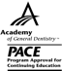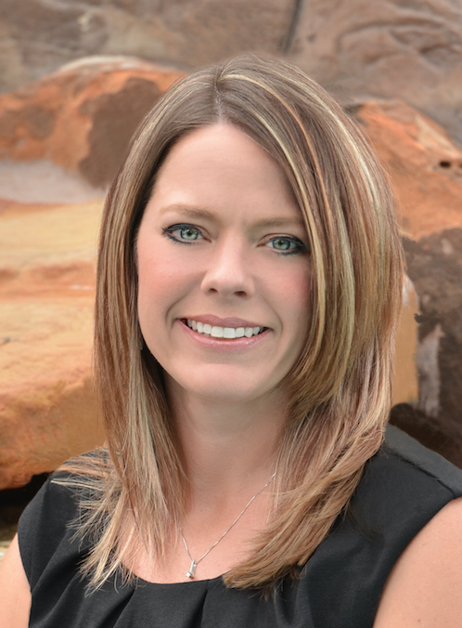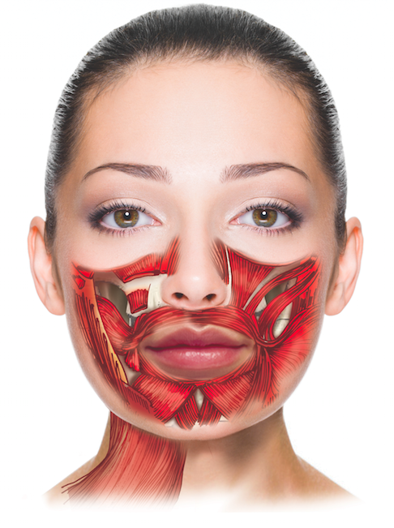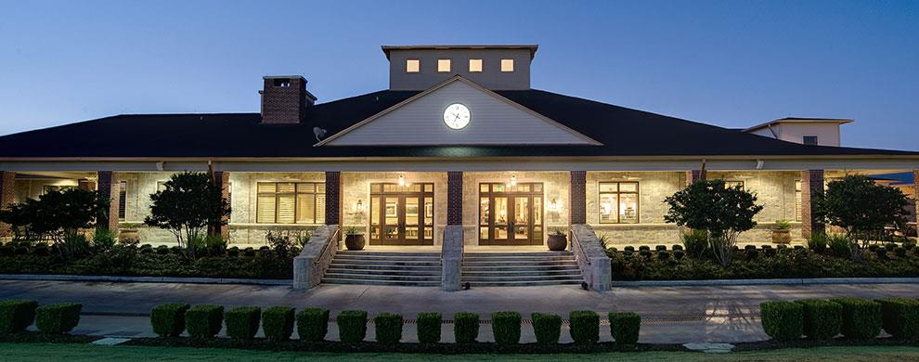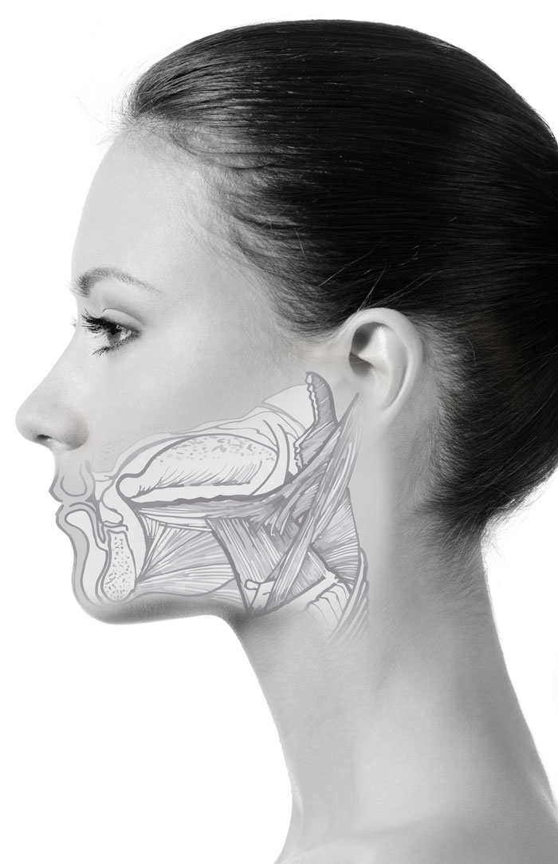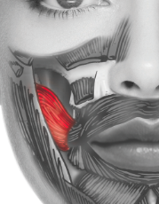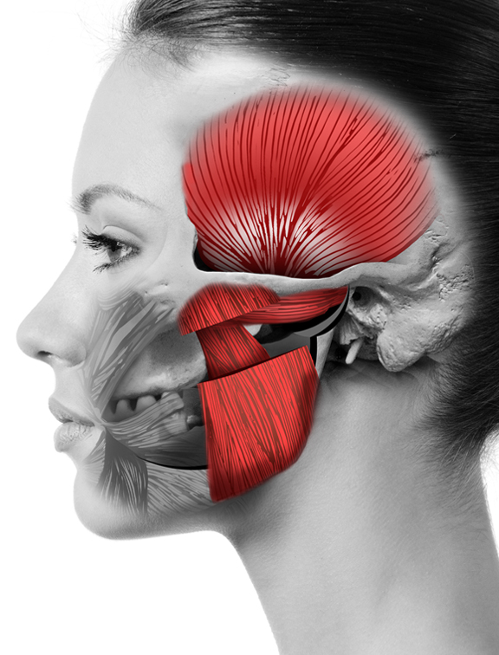

This program is offered for 2.8 CEUs (Introductory level, Professional area)

This course provides the participant with a comprehensive understanding of the foundations in orofacial myology. Parameters include developmental anatomy/physiology, dental, speech, medical etiologies, diagnostics, treatment planning, habit elimination, ethical scope of practice considerations and the didactic interaction of the orofacial complex from birth.

SLC@Home

16531 Chalk Maple Lane, Houston, Texas 77095

Kristie@slchouston.com

Kristie Gatto, MA, CCC-SLP, COM

2016 Course Dates:

June 23-26, 2016

July 14-17, 2016

November 10-13, 2016

## Course Description

A 4-day, 28-hour (2.8) Comprehensive Introductory course to

Orofacial Myology

Kristie Gatto, MA, CCC-SLP, COM received her bachelor’s and master’s degrees from the University of Houston in Houston, Texas. In 2004, Ms. Gatto became the co-owner of a private practice in Northwest Houston and began her journey in treating children with pediatric feeding disorders. After years of searching for answers in traditional feeding approaches, she underwent training in the field of Orofacial Myology and became the first certified orofacial myologist in the city of Houston in 2011. Ms. Gatto is currently the owner of The Speech and Language Connection, which has two offices in the greater Houston area and employs 24 speech-language pathologists with various specialties.

Ms. Gatto is a member of the American Speech-Language-Hearing Association (ASHA), International Association of Orofacial Myology (IAOM), and American Academy of Private Practice in Speech Pathology & Audiology (AAPPSPA), Texas Speech-Language-Hearing Association (TSHA), and Houston Association for Communication Disorders (HACD). Additionally, she serves on the board of directors for the IAOM and AAPPSPA and the Community Advisory Board for the University of Houston.

## Speaker: Kristie Gatto, MA, CCC-SLP, COM

Understanding the Orofacial Complex

Kristie Gatto, MA, CCC-SLP, COM

To register, please contact: [Kristie@slchouston.com](mailto:Kristie@slchouston.com)

281.682.2659

281.798.5679

Registration Fee: Please call for fees

Includes:

Understanding the Orofacial Complex: Text

Muscle Manual

Handouts and sample forms

Treatment supplies

Financial disclosures: Ms. Gatto receives monetary fees for speaking. Additionally, materials provided consist of books that were created as a for-profit means.

Non-Financial disclosures: Ms. Gatto is the President-Elect for the IAOM, on the Board of directors for AAPPSPA and the Community Advisory Board at the University of Houston.

**Day 4**

Comprehensive Assessment

Evaluation Summary (Q&A)

Therapeutic exercises

Habituation

Speech Patterns

Documentation

Business Management

**Day 2**

Physiology of the Swallow

Anomalies of the craniofacial structures

Comprehensive Case History  
Comprehensive Assessment

Photography in assessment

**Day 1**

IAOM History and Background

Certification Information

Scope of Practice and Ethical considerations

Embryology and Facial Development

Hard and soft tissues of the Orofacial Complex

Dentition

# Registration information:

Coursework will be taught:

14500 Houston National Blvd

Houston, Texas 77095

Kristie is an amazing teacher who takes her time to present the information in a very concise but simple way to understand.  She is open to questions and really is attune to the student’s needs and levels of learning.

**Day 3**

Treatment Hierarchies

Photography in treatment

Universal Precautions

Application of the Hierarchy

Non-nutritive sucking habits

Wendy Agero, MS, CCC-SLP